**ASSIGNMENT 2 FRONT SHEET**

|  |  |  |  |
| --- | --- | --- | --- |
| **Qualification** | **TEC Level 5 HND Diploma in Computing** | | |
| **Unit number and title** | **Unit 43: Internet of Things** | | |
| **Submission date** |  | **Date Received 1st submission** |  |
| **Re-submission Date** |  | **Date Received 2nd submission** |  |
| **Student Name** | Bùi Hương Linh | **Student ID** | GBH200662 |
| **Class** | GCH1002 | **Assessor name** | Le Anh Ngoc |
| **Student declaration**  I certify that the assignment submission is entirely my own work and I fully understand the consequences of plagiarism. I understand that making a false declaration is a form of malpractice. | | | |
|  |  | **Student’s signature** | Linh |

**Grading grid**

|  |  |  |  |  |  |  |
| --- | --- | --- | --- | --- | --- | --- |
| P5 | P6 | P7 | M5 | M6 | D3 | D4 |
|  |  |  |  |  |  |  |

|  |  |  |
| --- | --- | --- |
| **❒ Summative Feedback: ❒ Resubmission Feedback:** | | |
| **Grade:** | **Assessor Signature:** | **Date:** |
| **Internal Verifier’s Comments:** | | |
| **Signature & Date:** | | |

Table of Contents

Introduction 4

Task 1 – Develop the IoT application (P5-P6) 4

I. Employ an appropriate set of tools to develop your plan into an IoT application (P5) 4

1. Abstract 4

2. Different tools that need when developing 4

3. Design model 6

4. Implement code 7

II. Run end user experiments and examines feedback (P6) 9

1. User experiments feedback 9

2. Review user feedback 14

Task 2 – Test and evaluate the user feedback (P7) 15

Conclusion 15

Link demo: 15

References 15

Figure 1: ESP32-CAM 4

Figure 2: Camera module OV2640-V1 5

Figure 3: FTDI 6

Figure 4: Face recognition system design 6

Figure 5: Implement code (1) 7

Figure 6: Implement code (2) 7

Figure 7: Implement code (3) 8

Figure 8: Implement code (4) 8

Figure 9: Implement code (5) 9

Figure 10: Survey question (1) 10

Figure 11: Survey question (2) 10

Figure 12: Survey question (3) 11

Figure 13: Survey question (4) 11

Figure 14: Survey question (5) 12

Figure 15: Survey question (6) 12

Figure 16: Survey question (7) 13

Figure 17: Survey question (8) 13

Figure 18: Survey question (9) 14

# Introduction

I'm currently work as a product developer for a new startup where you design IoT products for the consumer, corporate, government and defence clients. Your manager has tasked you with planning and developing a new IoT product, service, or application for a potential client. In this report, I will have to complete the product as well as conduct testing with users and users will feedback and evaluate the product.

# Task 1 – Develop the IoT application (P5-P6)

1. Employ an appropriate set of tools to develop your plan into an IoT application (P5)
2. Abstract

Currently, in the educational environment, ensuring security is very necessary for students to be able to go to school with peace of mind. But security in schools is quite lax and face scanning system has been deployed and it is extremely necessary for schools. At the same time, this device will take attendance to record students' entry and exit times for instruction teachers can be caught.

1. Different tools that need when developing

**ESP32-CAM:** The ESP32-CAM is a small camera module that costs around $10 and uses the ESP32-S chip. It has a microSD card slot for storing images taken with the camera or files to serve to clients, in addition to the OV2640 camera and several GPIOs for connecting peripherals. (randomnerdtutorials.com, 2022)

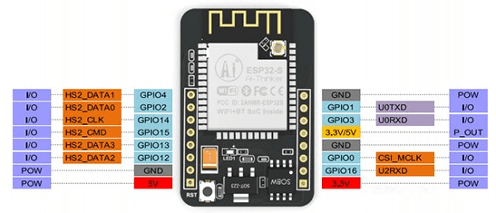

Figure 1: ESP32-CAM

Here is a list with the ESP32-CAM features:

* The smallest 802.11b/g/n Wi-Fi BT SoC module
* Low power 32-bit CPU, can also serve the application processor
* Up to 160MHz clock speed, summary computing power up to 600 DMIPS
* Built-in 520 KB SRAM, external 4MPSRAM
* Supports UART/SPI/I2C/PWM/ADC/DAC
* Support OV2640 and OV7670 cameras, built-in flash lamp
* Support image WiFi upload
* Support TF card
* Supports multiple sleep modes
* Embedded Lwip and FreeRTOS
* Supports STA/AP/STA+AP operation mode
* Support Smart Config/AirKiss technology
* Support for serial port local and remote firmware upgrades (FOTA)

(randomnerdtutorials.com, 2022)

**Camera module OV2640 - V1:** is a popular electronic component that works with the ESP32 module to receive the "take photo" command, take a picture and save it to memory, and then display it. Using the browser, display the newly captured image on the computer connected to the ESP32 board. (randomnerdtutorials.com, 2022)

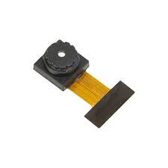

Figure 2: Camera module OV2640-V1

**FTDI Programmer:** The FT232RL USB to TTL 3.3V/5V FTDI Serial Adapter Module is a widely used module for connecting a TTL serial communicating device to a PC via a USB mini port. The jumper on the board allows you to select different output voltage options for this converter module. Any legacy peripheral can be upgraded to USB using the FT232RL USB to TTL Serial Adapter Module. (electronation.pk, 2022)

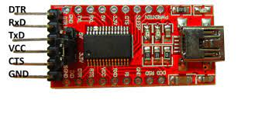

Figure 3: FTDI

This section mentions some of the features and specifications of the FT232RL USBto TTL Converter:

* Operating Voltage: 5V/3.3V DC
* Max Current Draw: 5V - 500mA; 3.3V - 50mA
* Connector: Mini USB
* Fully integrated 1024-bit EEPROM storing device descriptors and CBUS I/O configuration
* Data transfer rates from 300 baud to 3 Mbaud (RS422, RS485, RS232) at TTL levels
* 128 byte receive buffer and 256 bytes transmit buffer
* Transmit and receive LED drive signals
* Fully integrated clock generation with no external crystal required

(electronation.pk, 2022)

1. Design model

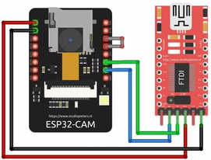

Figure 4: Face recognition system design

1. Implement code

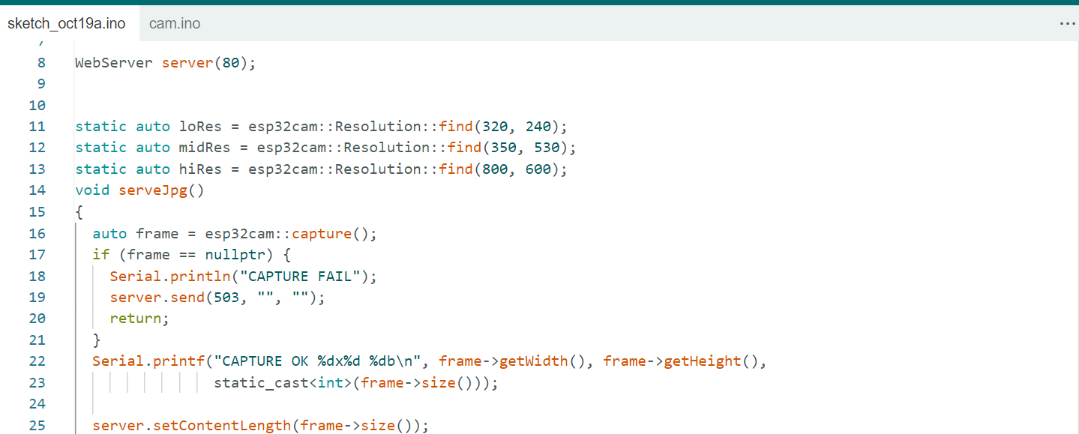

Figure 5: Implement code (1)

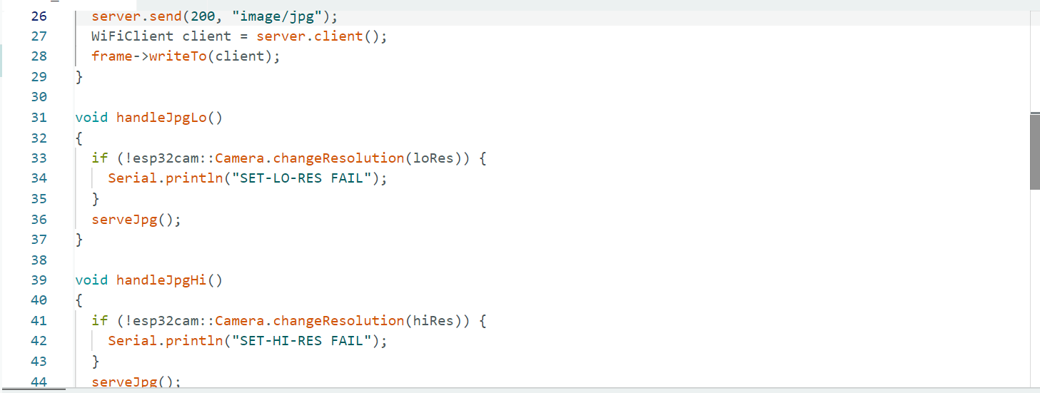

Figure 6: Implement code (2)

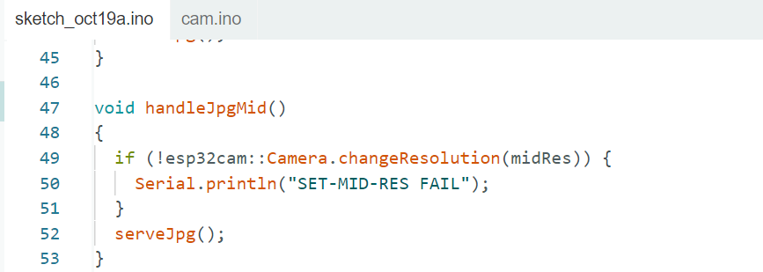

Figure 7: Implement code (3)

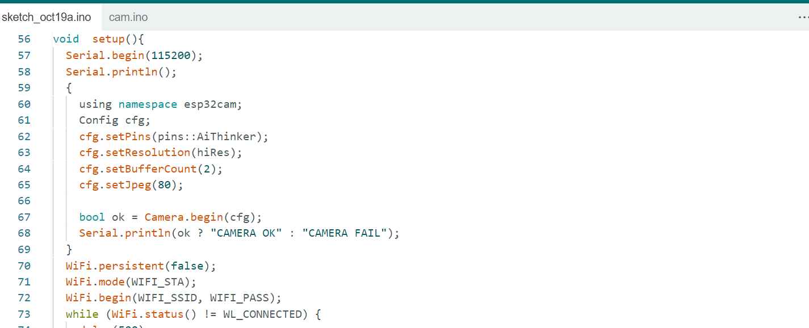

Figure 8: Implement code (4)

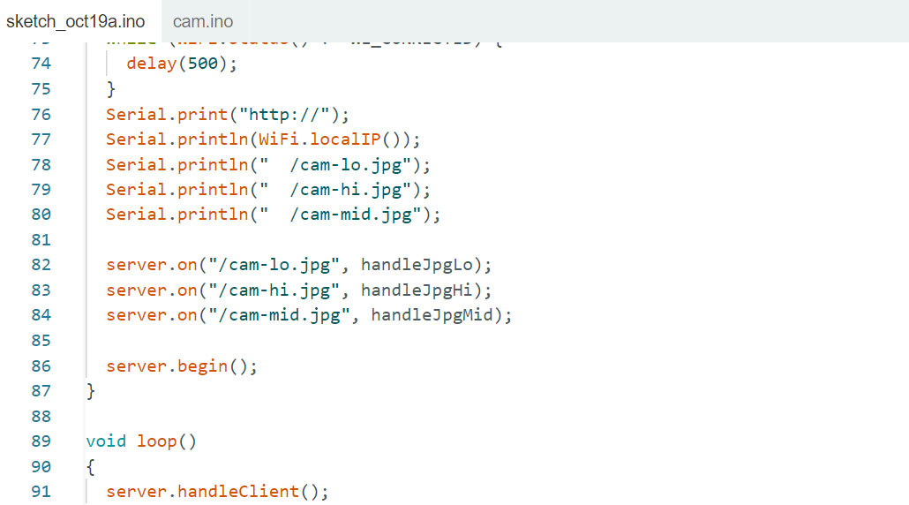

Figure 9: Implement code (5)

1. Run end user experiments and examines feedback (P6)
2. User experiments feedback

User feedback is information and opinions collected from users about their experience using our products. In this section, we have created for users a google form so that customers can objectively evaluate our products. After collecting feedback, we will review and filter the comments to improve the product as best as possible.

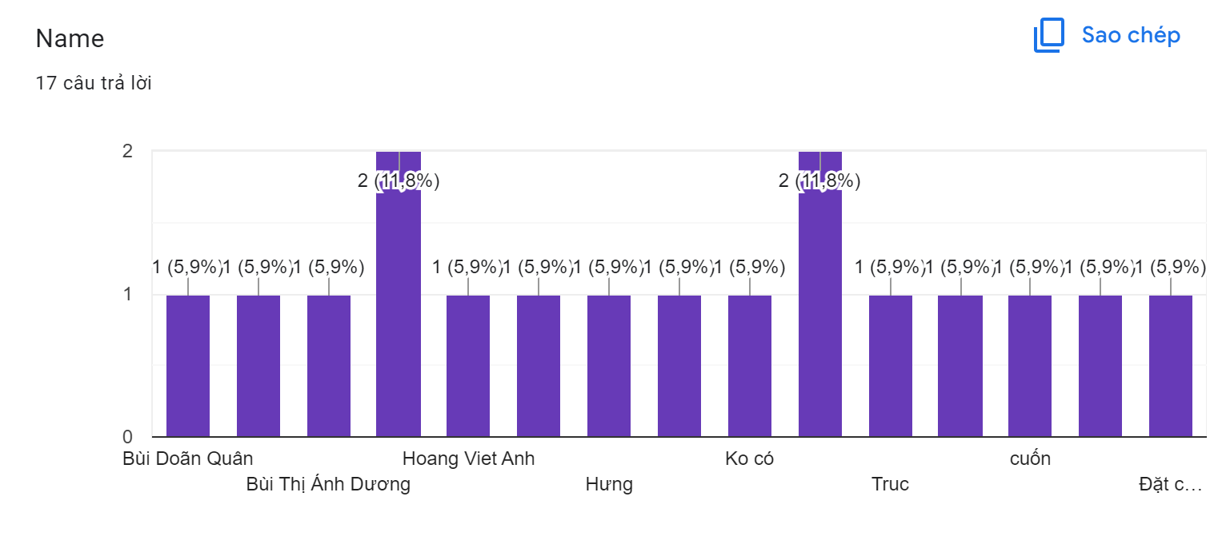

Figure 10: Survey question (1)

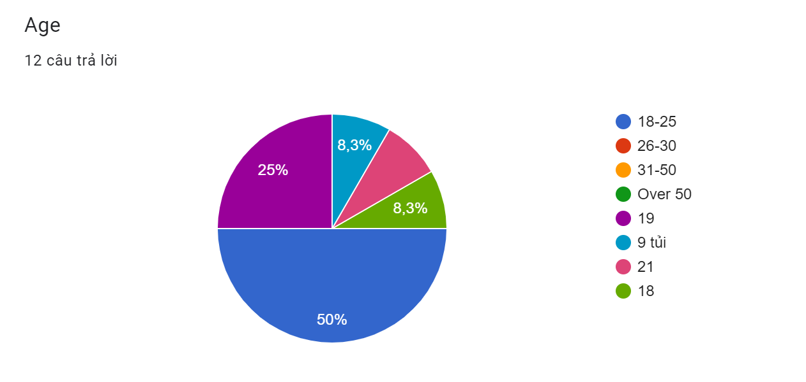

Figure 11: Survey question (2)

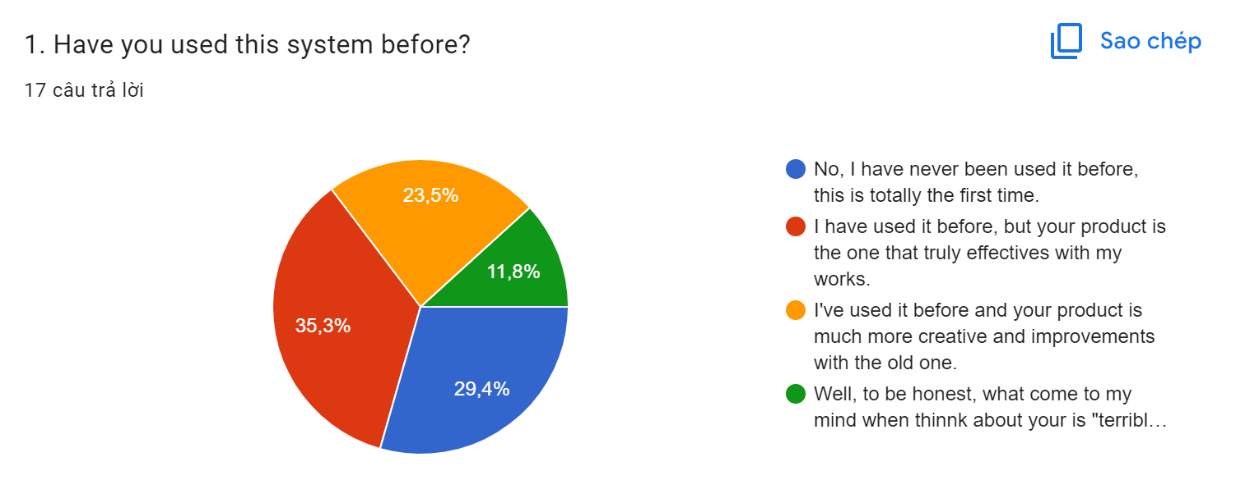

Figure 12: Survey question (3)

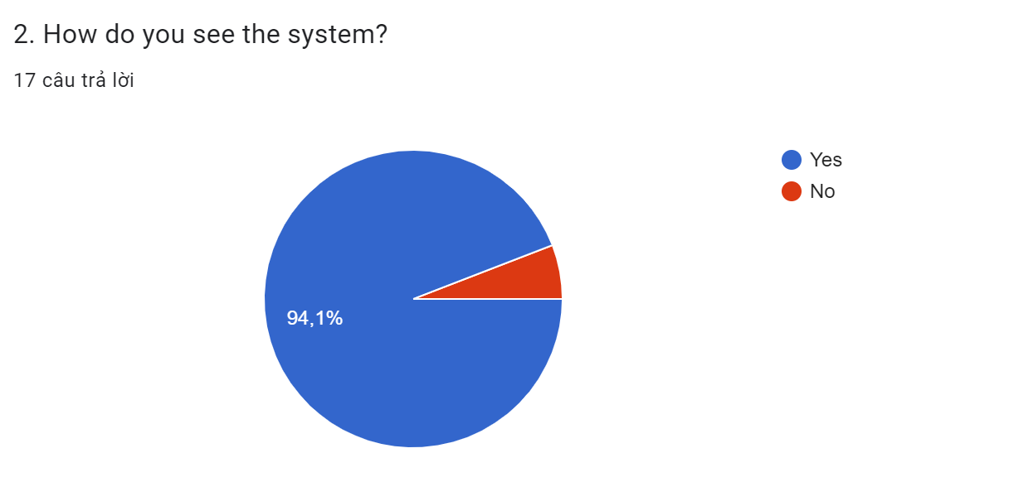

Figure 13: Survey question (4)

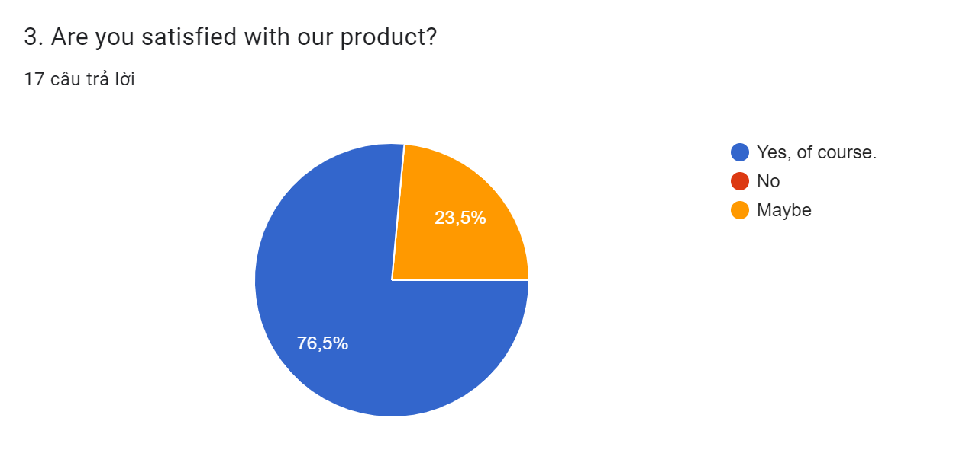

Figure 14: Survey question (5)

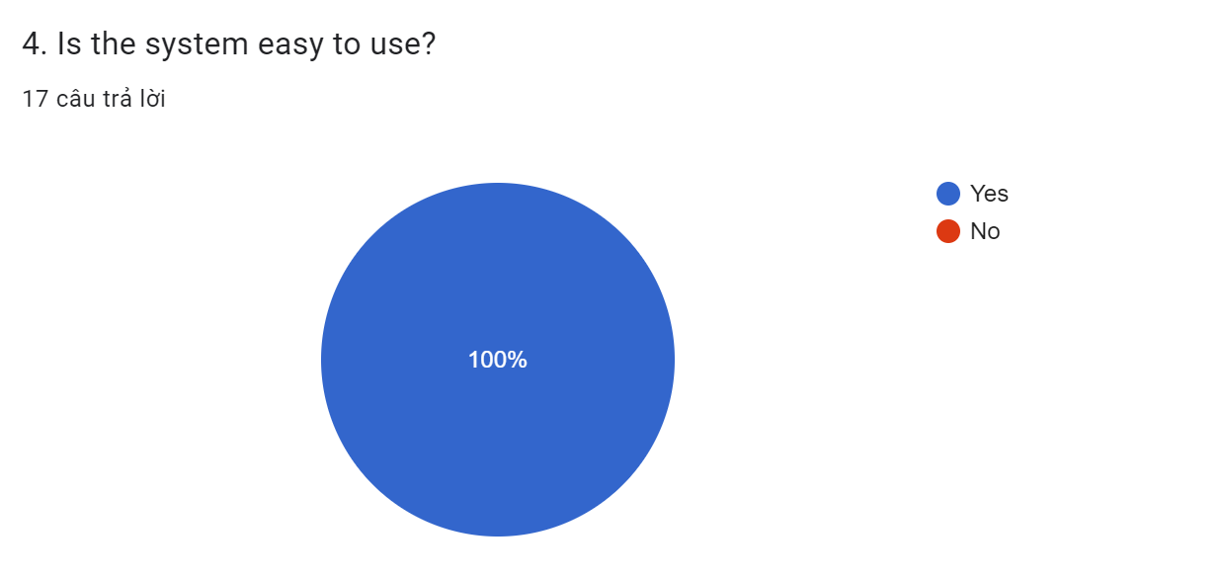

Figure 15: Survey question (6)

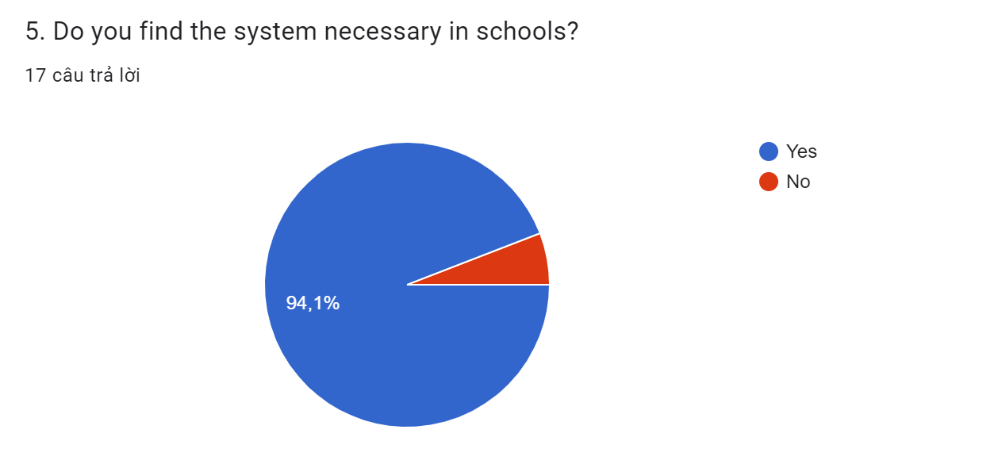

Figure 16: Survey question (7)

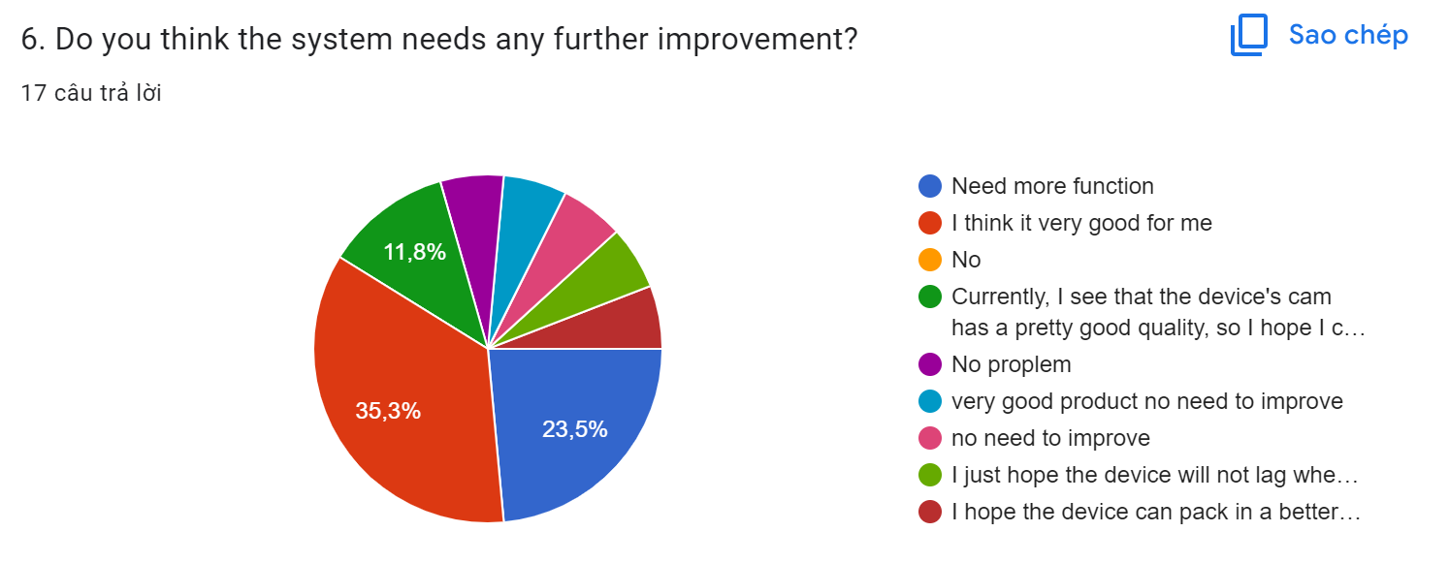

Figure 17: Survey question (8)

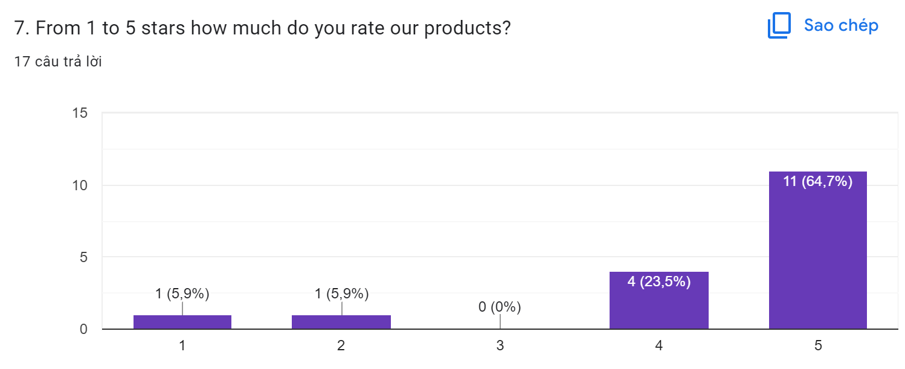

Figure 18: Survey question (9)

1. Review user feedback

Face-scanning systems are becoming more and more important as students increase and truancy becomes more common. Many sources believe that schools around the world are solving this problem. With different applications, we can improve the system through user feedback. Basically, thanks to modern technology and we will take advantage of what we have learned through IoT. Smart devices are gradually becoming more common in daily life as technology advances.

Through the survey, we learned a few things:

First, the accessibility of the product is extremely good. Almost everyone knows about the product as evidenced by the age of survey participants from 9 to over 50 years old.

Second, the popularity of this technology is extremely large. About 70% of survey respondents have used the product before. it really helps them in work and study. And the remaining 30% is that they have never used this product.

There are no negative reviews for our products. The reviews are all positive and our product will be a big turning point in technology and life.

The applicability in schools is highly appreciated by everyone. This means that facial recognition systems have the potential to be applied in today's educational environment. Only about 5% of users disagree that the product can be used in an educational environment.

Finally, with nearly 65% ​​of users rating the product 5 stars. I think my product is excellent and useful.

## Task 2 – Test and evaluate the user feedback (P7)

Student management in schools is an important part of the system we create. In schools, facial recognition systems are still scarce, leading to students skipping school, asking others to study for them, etc.

According to feedback, some people want to add functionality, others think the system is good for schools. But we will widely advertise to schools that use facial recognition systems to replace attendance for the purpose of students skipping class, asking for help, ....

Facial recognition is software that identifies or confirms a user's identity by their face. This product is very useful in the educational environment we are aiming for. This system works by identifying human facial features through images fed into a computer. This system can recognize the face whether the face matches the image stored in the system. The system helps users to verify quickly and efficiently. Facial recognition system brings great benefits to schools because it will help reduce dropout rate and help students learn on behalf of students.

Benefit:

* Effective security
* Easy to install
* Make quick identification

Defect:

* The accuracy is not high because when the identification can be mistaken for another person.
* When adding users, it is quite time consuming.

# Conclusion

Through the above report, I have learned the lesson that I can fully use available technology such as IoT. Facial recognition system is quite popular in the field of employee management, .... Hopefully in the education system, facial recognition system will be more popular.

# Link demo:

https://drive.google.com/file/d/1Xkepikvl2Hn-SKPUjUqhSE9DSvgBkRWU/view?usp=sharing

# References

electronation.pk, 2022. *USB to TTL FTDI 232.* [Online]   
Available at: https://electronation.pk/product/usb-to-ttl-ftdi-232/

randomnerdtutorials.com, 2022. *ESP32-CAM Video Streaming and Face Recognition with Arduino IDE.* [Online]   
Available at: https://randomnerdtutorials.com/esp32-cam-video-streaming-face-recognition-arduino-ide/?fbclid=IwAR279DQZ_bnFFzKx1J1kxvDDoyH8aaqS6JZA1zIPmqYzYKzR5b9cCc-g54c